Link to github and youtube video

[Donel21/Mast5112: Mast part 2 (github.com)](https://github.com/Donel21/Mast5112)

[Donel21/Mast5112: Mast part 2 (github.com)](https://github.com/Donel21/Mast5112)

[How I created my chef app using reactive native (youtube.com)](https://www.youtube.com/watch?v=MShGWEzhQcQ)

[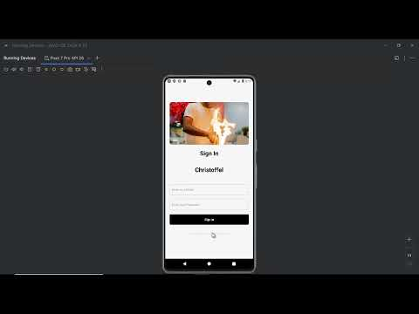](https://www.youtube.com/watch?v=MShGWEzhQcQ)